XCAD7311

POE Documentation

ST10028039 – Mehluli Ofentse Booi

ST10209476 – Lesego Ramosa

ST10092086-Lwazi Mesatywa

Table of Contents

Requirement 3

User Roles 3

Admin: 3

Registered User Role: 3

Guest/Anonymous User role 3

Developer Role 4

User Stories 5

User Experience Journey Map 5

Non- functional requirements 5

Portability 6

Scalability 6

Usability 6

Reliability 6

Implementation Document 6

DevOps 6

GitHub Action Pipeline 6

Running Costs & Projections for the Website 6

Hosting Plan: 6

Extra Costs to Consider: 7

Growth Plan: 8

Final Cost Projections Over Two Years: 8

References 9

# Requirement

## User Roles

For this web application we have decide to go with these five User for this application to help ensure security, control and an organized workflow:

### Admin:

**Permissions:**

* Unrestricted access to all the system settings and features.
* Monitor usage and generate reports
* Create, update, delete user accounts and roles.
* Manage all data, including viewing, editing and deleting records.
* Control of system setting, backups and logs

**Use Case:**

* Admins are people who will be responsible for overseeing management and maintenance of the application.

### Registered User Role:

**Permissions:**

* Access to basic features, such as creating profile submitting contract forms
* Being able to leave reviews and start rates
* Limited access to edit and view their personal data

**Use Case:**

* Registered users are customers or regular users who access to features that require accounts like booking a service.

Guest/Anonymous User role:

**Permissions:**

* Cannot create, edit, or delete any data
* Limited access to view public content like be allow see landing page but not being to request services
* No account personalized features like the profile features, comments and reviews

**Use Case:**

* Guest are able to browse the web application but have to register for more features.

Developer Role:

**Permissions:**

* Access to developer tool such as code repositories, system configurations and debugging logs
* Limited access to admin settings but has privileges related to maintenance and development
* Deploy updates or roll back changes

**Use Case:**

* To work the technical aspect of the application like bug fixes and updates.

## User Stories

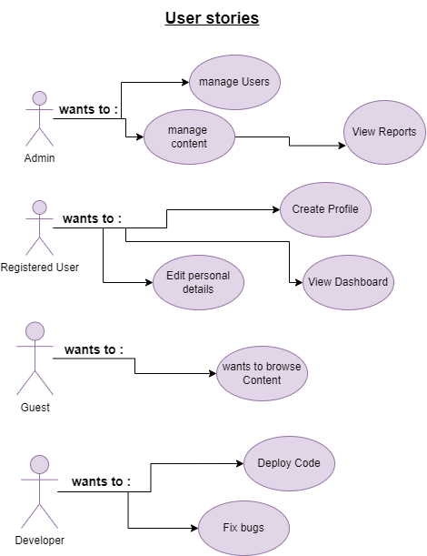

## User Experience Journey Map

# Non- functional requirements

Non-functional requirements define how a system operates rather than what it does. They focus on performance, reliability, and usability, helping to shape the system's overall quality and constraints. Below are the key non-functional requirements for this web application:

Portability - ensuring that the web app focuses on having put portability as a requirement is important as it gives the business or company a chance to get users attention from the phone in their hands to the desktop at home and having browser support.

Scalability - is one of the most important requirements as this is an ever-growing business so the web application is to needs grow to be able to handle the business's needs and digital foot traffic.

**Device responsiveness** to support horizontal and vertical scaling

Usability – is a requirement the web app needs to have like **ease of use** with the UI for users can navigate with little to no guidance.

**Accessibility** standards so that user with disabilities can use the system effectively

**Multilingual system** to accommodate all users from different regions and languages.

Reliability –

System is to have a robust design that allows us to keep the website running 99% of the time so that any possible customers can make use of the website

**Data backups** at regular intervals as it would help with any system crashes bugs problems of corruption.

# Implementation Document

# DevOps

What are DevOps? they are a set of tools and practises which have been created to help bridge the gap between software development (Dev) and IT operations (Ops) hence why we have the Dev and OPS as it emphasizes on collaboration and communications between operation and development teams

## GitHub Action Pipeline

# Running Costs & Projections for the Website

## Hosting Plan:

Based on the client's input, a shared hosting plan is ideal for keeping the project within budget while meeting the necessary performance requirements. For example, Hostinger offers a shared hosting plan with the following key features:

* 3 GB RAM
* 2 CPU cores
* Unmetered bandwidth
* 30 GB SSD storage

At $3 per month for a 48-month plan, the costs will be:

Hosting Cost:

- Monthly Cost: $3/month

- Annual Cost: $36/year

- Cost over 2 years: $72 (for 24 months)

- Cost over 4 years (projected): $144 (for 48 months)

This hosting plan provides sufficient resources for handling the website’s traffic, content uploads (such as images and updates), and potential customer interactions.

### Extra Costs to Consider:

**Domain Name:**

A custom domain (e.g., www.businessname.com) typically costs around $10–$15 per year, depending on the domain provider and extensions (.com, .co.za, etc.).

- Annual Cost: $10–$15

- Cost over 2 years: $20–$30

**SSL Certificate:**

For secure browsing, you might opt for a free SSL certificate (included with many hosting plans), but if you need a premium SSL, it could range from $5–$10 per year.

- Annual Cost (if premium): $5–$10

- Cost over 2 years: $10–$20

Predicted Total Monthly Costs (1st Year):

- Hosting: $3/month

- Domain: $0.83/month (if annual domain cost is $10)

- SSL: $0.42/month (if premium SSL at $5/year)

Total Monthly Cost (1st year): Approx. $4.25/month

**Growth Projections:**

As the business grows, especially in the first two years, traffic and customer engagement will increase. Here’s how the resource consumption may evolve:

**First Year:**

* Expect initial traffic to be manageable with the current hosting plan, and minimal updates to the site (content updates, additional images, etc.). The shared hosting plan will comfortably handle around 5,000–10,000 visitors per month.

**Second Year:**

* By the second year, as the business grows and gains traction, traffic may increase, requiring more frequent updates or added features like live tracking or real-time customer support. The shared hosting plan should still handle this, but if growth exceeds predictions, consider upgrading to a higher-tier hosting plan or a VPS (Virtual Private Server) plan, which could cost around $10–$15 per month.

### Growth Plan:

**Year 1:** Start with shared hosting at $3/month and maintain this setup to assess growth.

**Year 2:** Monitor traffic closely. If the site starts approaching the limits of the hosting plan (e.g., slower load times or increased downtime), we’ll consider upgrading to a VPS or cloud hosting for around $10–$15/month to accommodate higher traffic volumes and site functionality. (Glover, 2024)

### Final Cost Projections Over Two Years:

* Hosting: $72 for 2 years
* Domain: $20–$30 for 2 years
* SSL: $10–$20 for 2 years
* Total 2-Year Cost: Approx. $102–$122

This plan allows for the project to be quite scalable while ensuring that the website still is reliable and keeping costs low specially during the early stages of the project as well the approach optimises the cost and allows us to have breathing room for business digital presence as the user traffic increases

# References

Glover, J., 2024. *How Much Does It Cost to Host a Website? | Compare 2024 Prices.* [Online]   
Available at: https://www.websitebuilderexpert.com/web-hosting/cost-to-host-a-website/  
[Accessed 22 March 2024].